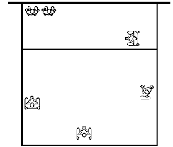
Right Side Attack

LB: line up with LF outside shoulder; cover line hits, line tips, and center tips
CB/L: Fill in hole in block, stay deep for hits and/or tips over blocks
RB/S: line up with M outside shoulder, cover angle hits, angle tips and center tips
RS: off towards 10 ft line, cover tips in 4/3/2 and center

EVERYONE “SQUARE UP” TO HITTER’S SHOULDER AND WATCH HAND!
LF/Outside Attack
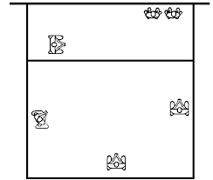

LB: line up with M outside shoulder; cover angle hits, angle tips, and center tips
CB/L: Fill in hole in block, stay deep for hits and/or tips over blocks
RB/S: line up with RS outside shoulder, cover line hits, line tips and center tips
LF: off towards 10 ft line, cover tips in 4/3/2 and center

EVERYONE “SQUARE UP” TO HITTER’S SHOULDER AND WATCH HAND!
Middle Attack
LB: line up with M outside shoulder; cover line hits, angle tips, and center tips
CB/L: Fill in hole in block, stay deep for hits and/or tips over blocks
RB/S: line up with RS outside shoulder, cover line hits, line tips and center tips, and tips at 2.
LF: off towards 10 ft line, cover tips in 4/3/2 and center

EVERYONE “SQUARE UP” TO HITTER’S SHOULDER AND WATCH HAND!

